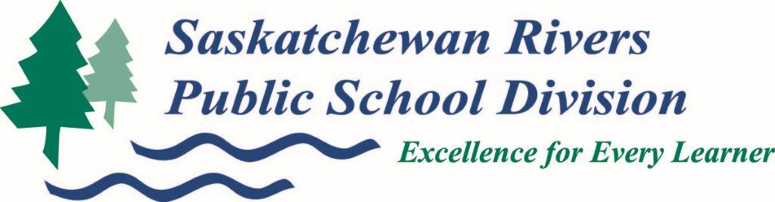
W.J. Berezowsky Public School
566 McIntosh Drive
Prince Albert, SK S6V 6T2
Phone: (306) 763-7404 Fax: (306) 763-4434

Dwayne Tournier, Principal
Marti White, Vice-Principal

March 10, 2020

Dear Families:

As you have probably already heard, beginning Thursday, March 12, 2020, a Restriction of Services sanction will be implemented province-wide for all STF members and will remain in effect until further notice.
Please be assured that the safety of students is our first priority. Staff will be onsite to supervise students 15 minutes prior to the first bell (8:35) and 15 minutes after the dismissal bell (3:00). Please be advised that our school doors will be locked until 8:20 and any students being driven to school must be picked up before 3:15 since no supervision will be provided after that time.
In addition, these sanctions will have the following impact on W.J. Berezowsky Public School:
- The After School Program will continue run while sanctions are in place.
- Parent Teacher Interviews are still happening on the evening of March 26th.
- Supervision and canteen at lunch is not affected.
- School doors will be locked till 8:20am and then locked again at 3:15
- All sports practices and games that have been scheduled for after school have been cancelled.
- No extra-curricular activities will be provided during recess, lunch or after school.

If you have any questions regarding the impact of these sanctions on our students, please feel free to contact me at (306)763-7404.

Mr. D. Tournier
Principal

